RECORDING and PLAYING SONGS
(By George Clark 4/16/2005)

Chap 1 Pg 2 Recording with Goldwave
Chap 2 Pg 11 Recording your own voice in a separate file for use with DanceMaster
Chap 3 Pg 12 Putting music on other media
Chap 4 Pg 13 Changing pitch and/or tempo
Appendix
Pg 14 Hooking up your Hilton to your computer
Pg 15 GoldWave setup

General Tempo comments:
If you use DanceMaster or SqView the tempo can be adjusted within the program
If you use Minidisks or CDs or MP3 players the player most likely does not tempo shift
(or does tempo shift and pitch shift at the same time)
If you use DanceMaster or SqView to record to minidisks or CDs or M3 players you can
set tempo when recording.
Otherwise you will need to save the MP3 at the tempo you need (see Chapter 4).

My rules for recording
Record all songs at 45 RPM so the pitch/quality is as produced.
Record all songs as monaural (Hilton Amp is mono) since the dance floor usually works better with monaural.
Clean up the recording (Pops/clicks/hiss) and maximize quality.
Don't adjust tempo (see above) on master saved files
For Rounds I use Dancemaster
For squares I use SqView

Standard steps - With GoldWave, WinAmp (+ DJ Helper & Pacemaker)
Record song
Clean it up
Remove lead-in and trailer
Save to WAV and MP3
Optional step:
Use WinAmp/DJ Helper (on MP3 file)
Measure tempo and save info in Tag file

PS – Any changes, corrections, additions, or improvements are gratefully accepted.
Just email me at georgec@promenadeshop.com
CHAPTER 1
RECORDING WITH GOLDWAVE

INITIAL RECORDING PREPARATION
(For initial setup of computer-amplifier and GoldWave see Appendix)
Clean the Record – this can remove a lot of noise and make the rest of the process easier.

Select New in GoldWave (Mono, 44.1k, 5 Minutes)
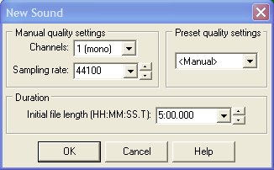

You should now see the Initial Screen just before recording.
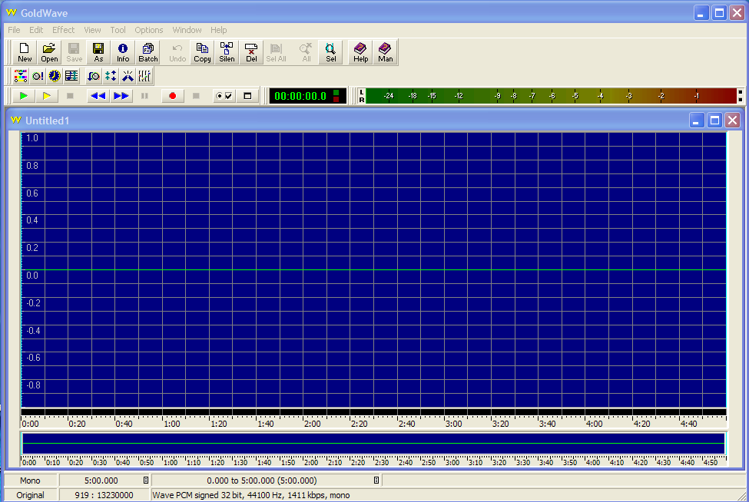
Set Recording Device and Volume level (pictures are for my USB device and also Microphone jack).
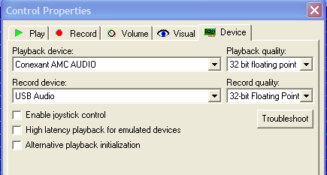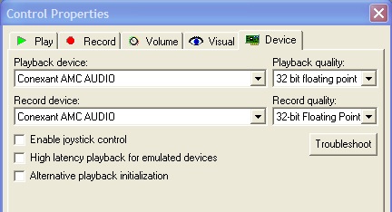

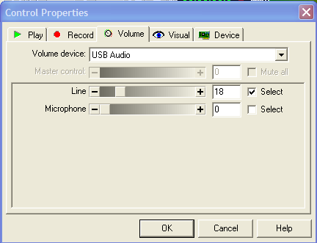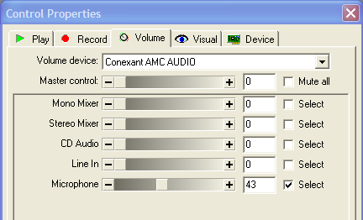

Record Music

Select Maximize and note "Current maximum" then click "Cancel"
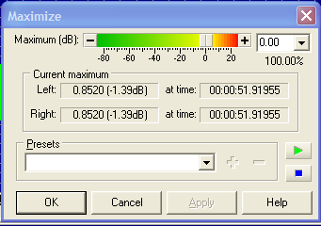
If Current Maximum is in the range of .50 to .99
Go on to "Process the Recording"
Otherwise
If Current Max is over 1 then clipping has occurred and the recording is distorted
Set volume (in control properties) to about 2/3 of old volume (or your best guess)
Select Undo to set the channel back to its original state.
(If you select Undo from the Edit Menu it should say “Undo Record")
Click on "All" to show the full 5 minutes again.
Record music and try again
If Current Max is too low
Select Undo to set the channel back to its original state.
(If you select Undo from the Edit Menu it should say “Undo Record")
Click on "All" to show the full 5 minutes again.
Record music and try again

Process the Recording
a) Select start of recording to start of music and select View Selection

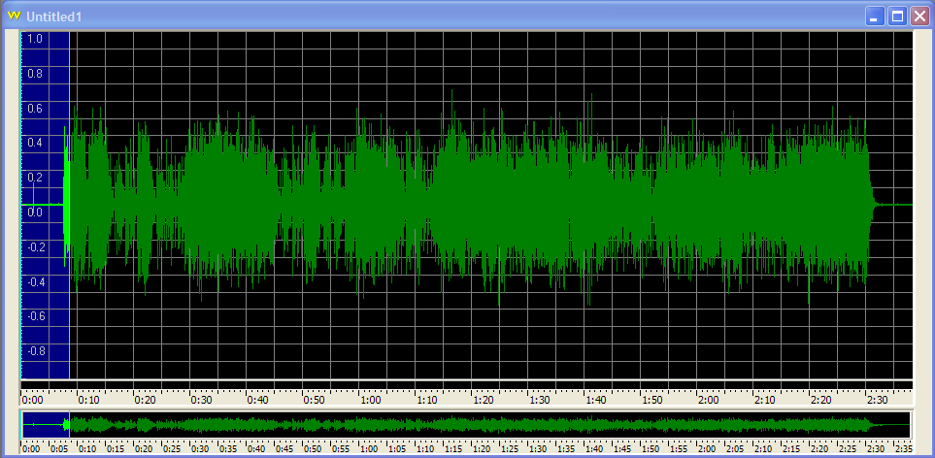
b) Select from point needle is down until almost the start of the music
and "Copy" (copy puts the selection on the clipboard)
Make sure you don’t select the initial high amplitude pops (from
Settingthe needle down) but start right after them. If you do select
them it may cause the modified recording to sound tinny.
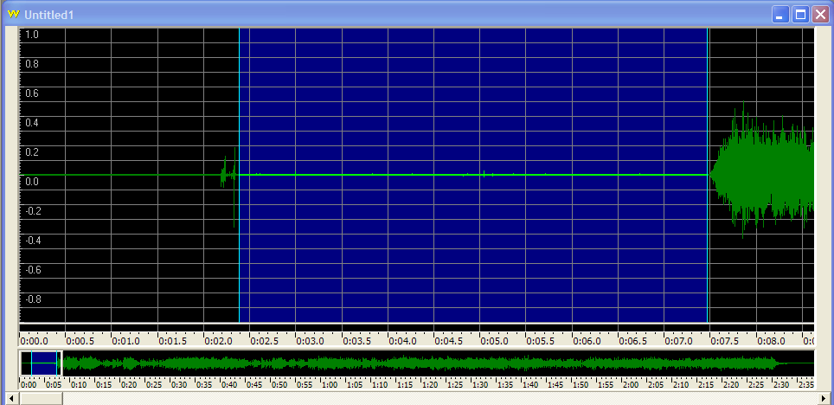

Click "Select all" so your are processing the whole recording and then click “Noise Reduction”
Set Reduction Envelope to "Use clipboard" and click "OK"
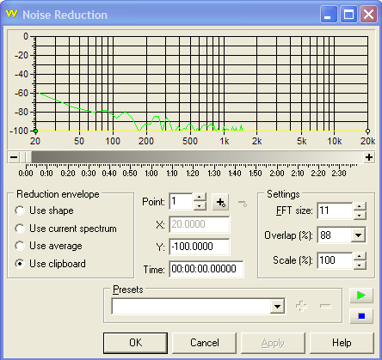

Select from start of recording up to start of music
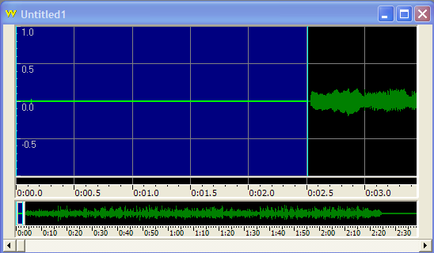
Select Delete
This will remove all of start up to the start of the music.
When playing there will be no delay when starting the music.

Select the tail end of the recording.
Repeat Delete to remove dead space at the end of the song.

"Select all" (Ctrl-A) and Maximize (Current Maximum should be less than 1.0)
Click on OK to complete Maximize

Optional Steps - any of these could really mess the recording up but you can always "Undo"
(I don't normally do any of these unless the recording is really bad)
Use Click/Pop to remove specific clicks and pops
This can either clean everything up or really mess things up. Listen to
the resultant file after performing this step to make sure.
You can try to remove clicks/pops by selecting the section of the recording and
expanding the window to show just the one click/pop and manually modifying it.
Use compressor/expander to increase low and decrease high volume levels.
For Expander (this can be handy on records that have very quiet sections)
Select Presets to "Boost Quiet Parts", Attack at 0.050 and Release at 1.000
Attack is very small so it will recognize quickly
Release is set large so it will fade slowly and not chop the end
You can make your own custom preset (see Appendix)
Threshold may need to be adjusted. Try the default and if unsatisfied try moving it.
Note: the green right arrow will play the music as if the conversion were complete.
If you like it then click the OK to make it permanent.
Or you can just convert and then Undo if you don't like it.
Make sure you look at the end of the recording as there will probably be some
residual noise you will need to delete.

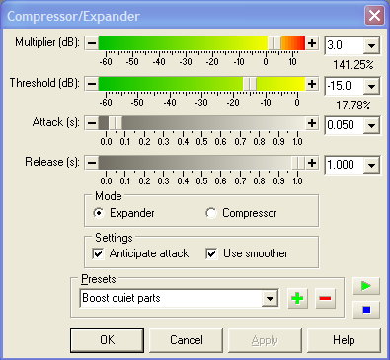

Fade can be used to clean up the end of a song if it ends too abruptly (like Birth Of The Blues)

Add "File: Information" Note: you can enter the time warp info if you plan on doing this to the MP3.
This is nice to have but not mandatory if you have good habits.
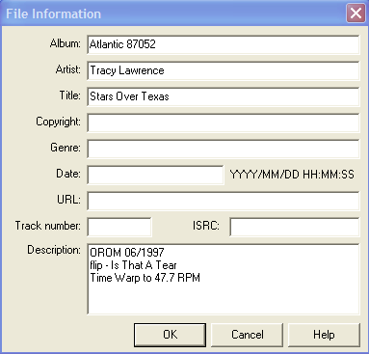

and SAVE to "Raw Music" select PCM signed 32 bit, mono
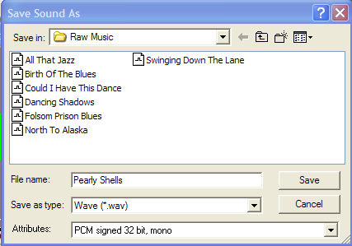

Save Pitch/Tempo change info in the Description box if you so desire.
Save to "Wave Files" select PCM signed 32 bit, mono
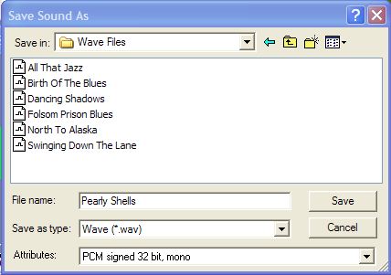

Convert to MP3 or wait and batch convert the files.
If you batch convert you will be able to select individual files or whole folders of them and sit back
and watch.
If you are going to adjust tempo/pitch then you will have to do individual file conversion.
After adjusting pitch/tempo select Save As and, after choosing the proper folder, set type as
MPEG audio (*.mp3) Layer-3, 44100 Hz, 128 kbps, mono.
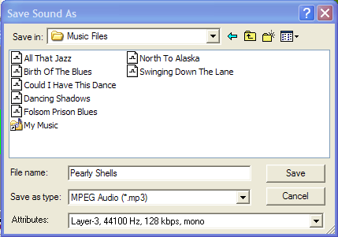

Note: Once I am sure files are like I want them then I archive the WAV files and MP3 files (save to CD/DVD/Tape/etc). Archiving the WAV files is important if you ever want to change anything.
Archiving the MP3 files is just for convenience. When finished archiving the WAV files you can
dump "Raw Files" and "Wave Files".
CHAPTER 2
RECORDING YOUR OWN VOICE IN A SEPARATE FILE
FOR USE WITH DANCEMASTER

Using GoldWave open a previously recorded song – the MP3 you will be using at the dances.
Open a "New" sound file (you should now have two files showing).
Connect your microphone so you can record into the new sound file.
(you can use the PC Mike input or go through the amplifier, Hilton, or other method).
Select Record and immediately Pause the recorder.
Select Play and then un-pause the recorder and cue the song.
When finished recording, stop the recorder, trim the leading and trailing blanks,
and save the file as an MP3 in the "Voice Files" (DanceMaster) folder.
(I don't know why you would want to but if you want to later change the tempo
you can also save as a WAV file.)

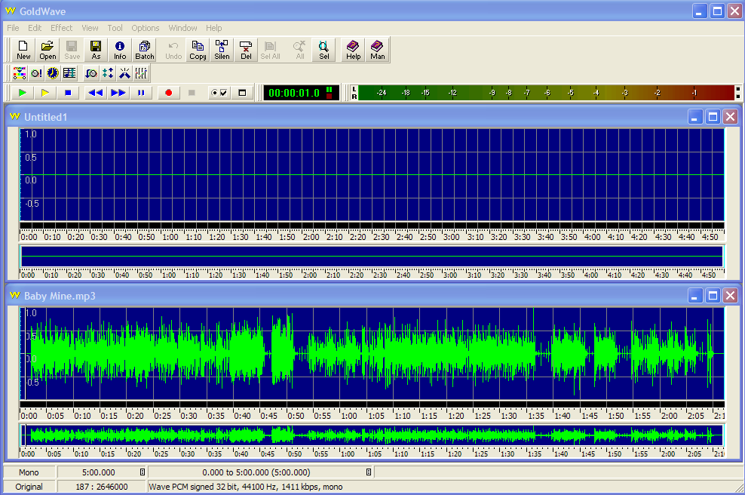

CHAPTER 3
PUTTING MUSIC ON OTHER MEDIA

If using Minidisk, With DanceMaster
(You will be recording the audio output of the laptop)
Enter the songs into the database
Set up a dance list in whatever playback order you want
(It's handy to save the list & print it out)
Select autoplay for dance list and get a cup of coffee (or two)
If you have lots of time you can record one, select the next one, record it, etc.
NOTE: If you use the minidisk in mono-record some players will reject the disk so use
stereo even though you are saving a monaural song
Dances will play one after another.
When done
If auto-recording, locate breaks and add marks
Label the recordings
If using Minidisk, NO DanceMaster
-Load WAV file into GoldWave and set tempo and save as MP3.
-OR load a pre-saved MP3 file.
-Using either GoldWave or WinAmp - play the song
-Label the recording
Repeat each step for for each song you wish to save to Minidisk

Using an MP3 player, or CD
Select the MP3 file - The file must be at the proper pitch and
tempo that you want for playback
Using normal transfer techniques copy the files over to the media
MP3 players usually come with software for this.
CDs can be recorded normally using your CD creation software.

CHAPTER 4
CHANGING PITCH AND/OR TEMPO

USE THE WAVE FILE (no degradation) (You did save it didn't you?)
Load the wave file into Goldwave
Select All (if not already selected)
Select Time Warp and note the length of the song
(for example 3:40.7287 which means 3 minutes, 40.7287 seconds)
Select Cancel to get out of Time Warp without changes
Select Pitch
Change semitones to what you require
Do NOT select "Preserve Tempo"
Select OK
(You now have the song with the pitch you need)
Select Time Warp
Calculate Length required (Using your own numbers)
Using example from above
3:40.7287 is 220.7287 seconds
To slow music by 2% multiply by 1.02 = 225.1433
To speed music by 2% multiply by 0.98 = 216.3141
If you only know relative tempo then use that value
45/Relative Tempo = multiplier
(43.5RPM = 1.0345 and 47 RPM = 0.9574)
Select the Length button
Convert to minutes and seconds and enter in the box to the right of Length
Set Algorithm to Similarity with default options
Select OK
Maximize
Put the Tempo/Pitch change info into the Info/Description box
(Don’t wanna forget what we just did)
Save as MP3
DO NOT OVERWRITE THE ORIGINAL WAVE FILE!!!!!

If using SQView then go in and clear the Pitch/Tempo info so program will play as saved.

If using DanceMaster then go in and clear the Tempo info and then re-time the Karaoke file.
I have requested a way to adjust the Karaoke file without having to do a complete retime.

APPENDIX

Hooking up your Hilton to your computer

You can use standard cables from the Hilton "Tape Music" port to the Microphone Input on your computer.
The Hilton output is Line Out so make sure you don't overdrive the computer

I use INPort which connects from the Hilton "Tape Music" port to the computer USB port.
This unit fully isolates potential ground loops or hum from the setup and is designed for Line Inputs.

I use DanceMaster as the do-everything application for Round Dance leaders
I have the following folders on my computer
Music Files and Voice Files in the default areas for DanceMaster
A General holding folder named "My Music" holding the following sub-folders
Raw Files
Wave Files
I use SqView for all hoedowns and singing calls (You can run both applications simultaneously with no problems)
All files are in the appropriate folders for SqView.

GoldWave Setup
The initial installation of GoldWave is described on the GoldWave web site. ( http://www.goldwave.com/ )
You can either use the shareware version (it nags you and limits the number of commands per session) or you can purchase it for about $45 US.
Once the program is installed you can preset several options as described below.

Generic Window Options
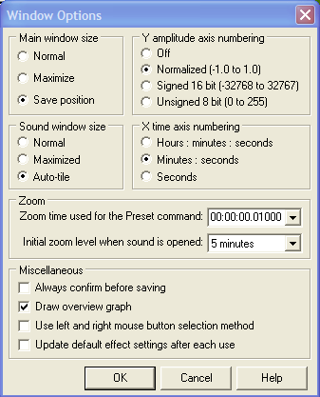

Most options indicated in the instructions can be set so a single mouse-click on the Toolbar is all that is required.

Main: [File| New, Open, Save, |Save As, Information, Batch Processing, Separator, Edit| Undo, Copy, Insert Silence, Delete, Select All, Separator, View| All, Selection, Separator, Help| Contents, Manual]

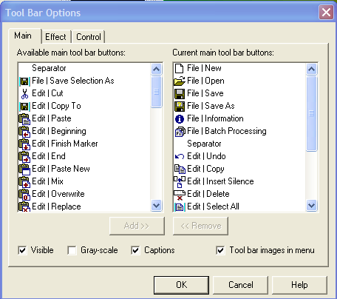

Effect: [Noise Reduction, Maximize, Time Warp, Pitch, Separator, Fade Out, Compressor/Expander, Pop/Click, Equalizer]
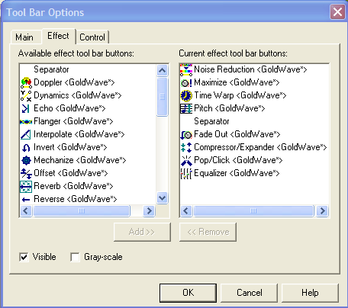

Control: All Boxes Checked
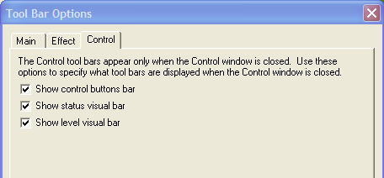

Time Warp can be set to minimize resetting values.
Set values where you want them and then enter a description in the Presets box (Note: By
placing an integer at the start this becomes the first entry in the table) and then click the
Green Plus sign to make the entry permanent.
For future usage you only need to select your Preset and adjust the Change value.
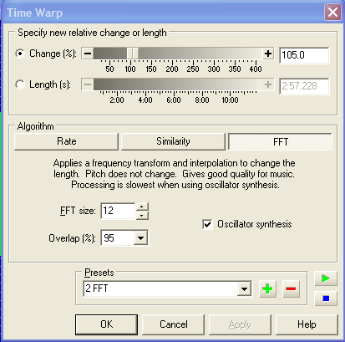

Compress/Expand can be set the same way as Time Warp to minimize extra clicks (and possible errors)

General Notes
To reset the clipped indicator (red box) right click on the bars area of the main screen and choose Properties
Click on the "Reset Clip" button and then OK
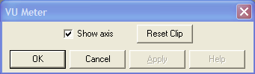
To select a region with the mouse:
If visible – click and hold the left mouse button, drag to the left till you reach the start, then drag to the right till you reach the end. Now release the button and the region will be selected.
If not visible – Do as above but use the small window (this shows the complete recording) below the main display to drag on.
When finished dragging - choose View Selection.

